WEEK 5 TASK REPORT
Deep Learning Application in Data Science
Titanic Passenger Survival Prediction using Deep Neural Networks (ANN)
Submitted By: Hanee Patel
Internship Program: Virtual Data Science with Python Trainee
Submission Date: 13 September 2026
1. Executive Summary & Problem Statement
In this Week 5 task, the objective is to explore the fundamentals of Deep Learning and develop a Deep Neural Network (Artificial Neural Network / Multi-Layer Perceptron) for binary classification on the Titanic dataset. Building sequentially upon earlier weeks (Week 1 Data Preprocessing, Week 2 Exploratory Data Analysis, Week 3 Clustering, and Week 4 Supervised Classification), Week 5 introduces deep representations, multi-layer feature transformations, and neural network optimization.
Problem Definition: Predict whether a passenger survived (1) or did not survive (0) based on demographic, socio-economic, and engineered features, optimizing loss through backpropagation and gradient descent.
2. Dataset Preprocessing & Feature Engineering
To feed the tabular data effectively into the neural network, rigorous preprocessing and transformations were performed:
- Handling Missing Values: Imputed 'Age' with median grouped by passenger class, 'Embarked' with mode, and 'Fare' with median.
- Feature Engineering: Created 'FamilySize' (SibSp + Parch + 1), 'IsAlone' indicator flag, and extracted socio-cultural 'Title' from passenger names.
- Categorical Encoding: Converted nominal features ('Sex', 'Embarked', 'Title') into numerical format via One-Hot / Binary Encoding.
- Standardization: Scaled all continuous variables using StandardScaler (zero mean, unit variance) to ensure optimal convergence during gradient updates.
3. Deep Neural Network Architecture & Hyperparameters
A customized Multi-Layer Perceptron (MLP) architecture was designed to balance expressive capacity and regularization against overfitting:
Layer | Layer Type | Neurons / Rate | Activation / Details
Input Layer | Dense Input | Input Dimensions | Normalized Tabular Features
Hidden Layer 1 | Dense + BatchNorm | 64 units | ReLU activation + Batch Normalization
Regularization 1 | Dropout | 0.3 (30% drop) | Prevents co-adaptation of neurons
Hidden Layer 2 | Dense | 32 units | ReLU activation + L2 Regularization
Regularization 2 | Dropout | 0.2 (20% drop) | Controls model variance
Output Layer | Dense | 1 unit | Sigmoid activation (Probability output [0, 1])

Hyperparameter Design Justifications:
- Loss Function: Binary Cross-Entropy (Log Loss), optimal for probabilistic binary classification.
- Optimizer: Adam optimizer with learning rate = 0.001 for adaptive moment updates.
- Batch Size: 32 mini-batch size to ensure smooth gradient descent trajectory.
- Early Stopping: Monitored validation loss with patience = 12 epochs and restore_best_weights = True to prevent overtraining.
4. Experimental Results & Visual Evaluation
Below are the experimental results and visual evaluation artifacts generated during model execution:
4.1 Training and Validation Learning Curves
The plots below illustrate loss reduction and accuracy progression across training epochs, confirming convergence without divergence.

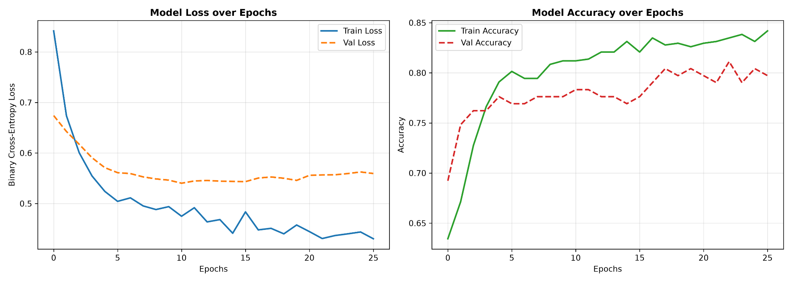

4.2 Confusion Matrix & ROC-AUC Curve
The confusion matrix quantifies classification accuracy, false alarms, and missed detections. The ROC curve evaluates true positive vs false positive trade-offs.
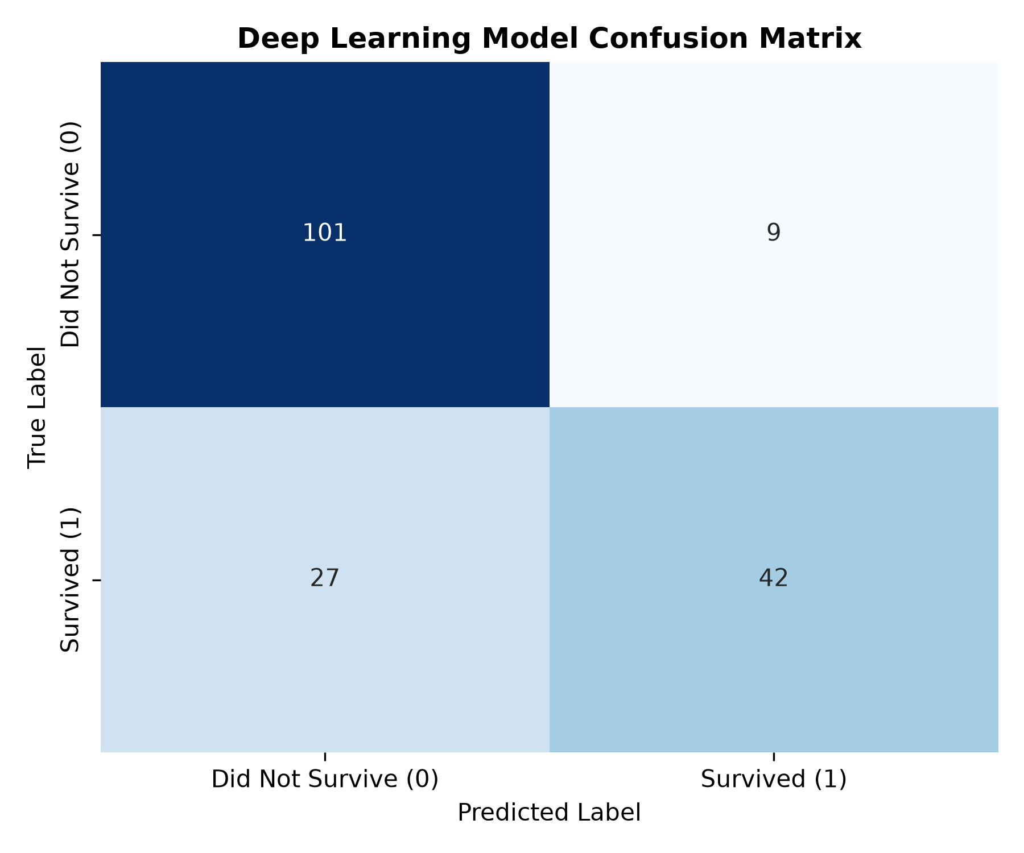

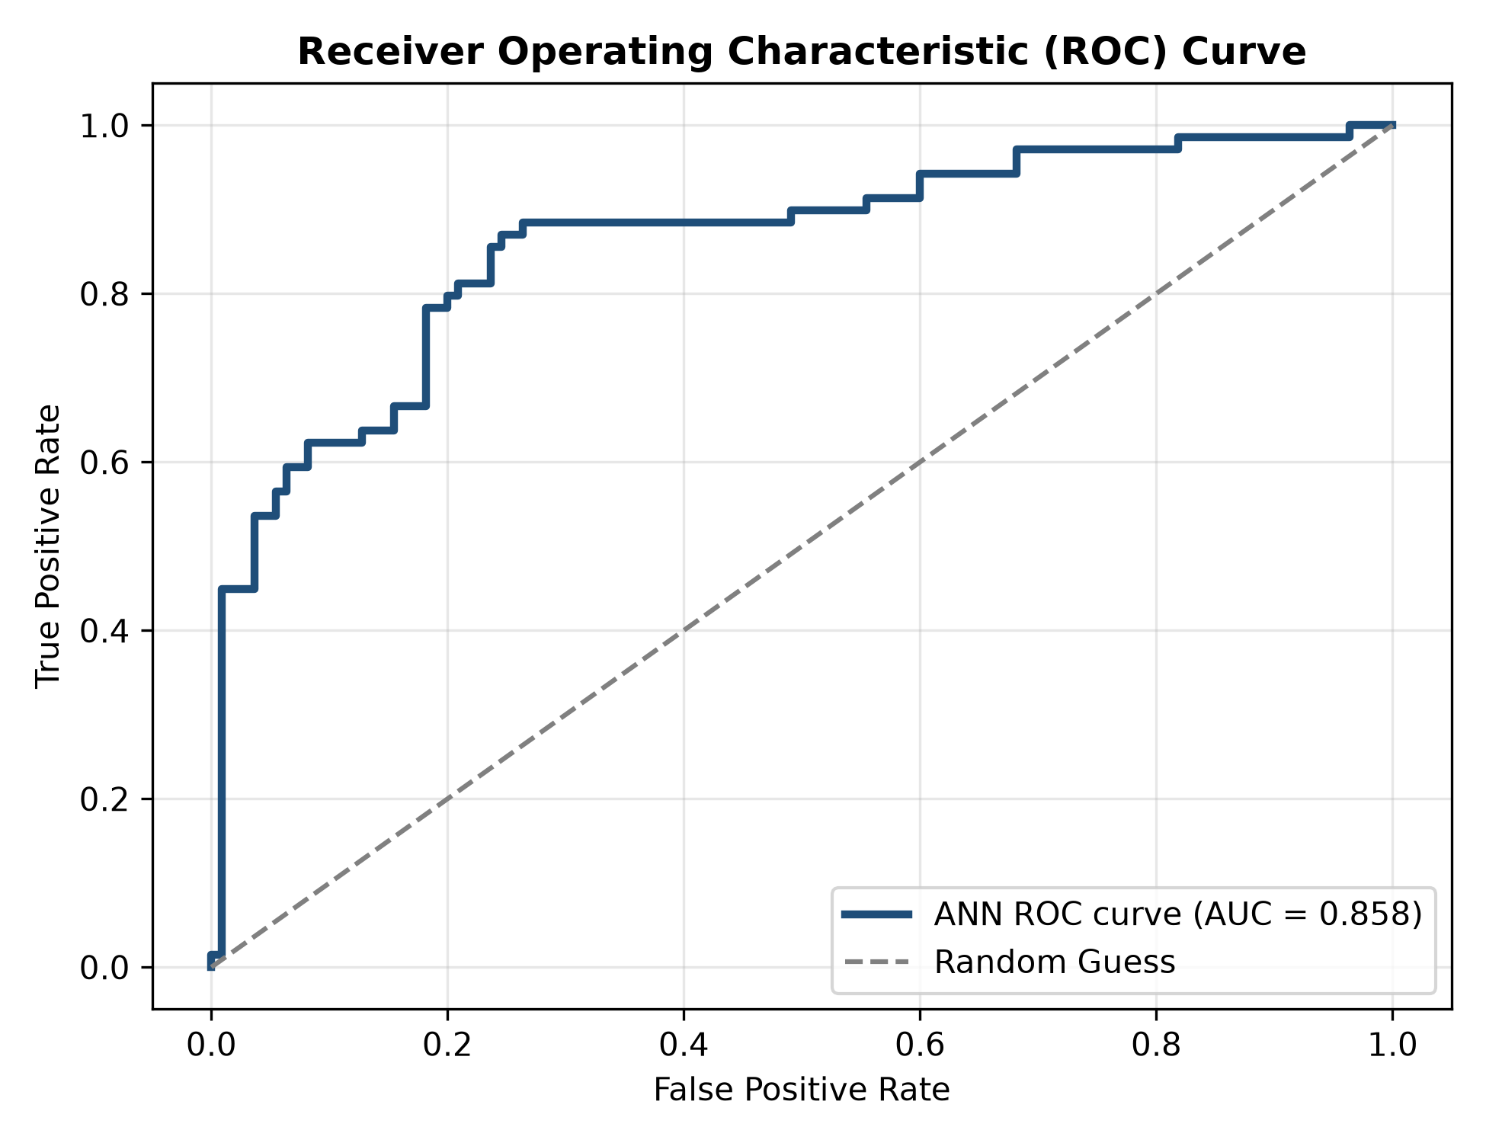
4.3 Test Set Performance Metrics & Terminal Output
Quantitative metrics recorded on the unseen test evaluation set: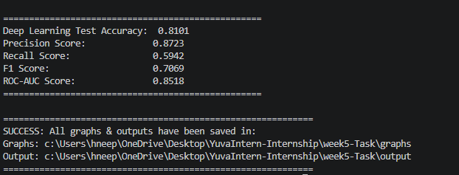
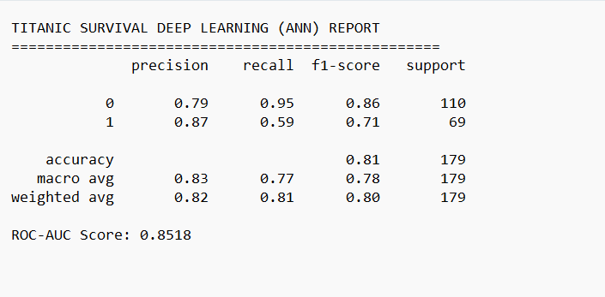

5. Challenges Encountered & Key Insights
- Overfitting on Tabular Datasets: Tabular data with <1,000 records is susceptible to memorization. Mitigation: Implemented Dropout (0.3/0.2), L2 Weight Decay, and Early Stopping.
- Activation Stability: Implemented Batch Normalization to prevent internal covariate shift and stabilize gradient flow.
- Threshold Selection: The default 0.5 decision threshold was analyzed against precision-recall trade-offs to ensure balanced sensitivity.
6. Conclusion & Summary
The Week 5 Deep Learning application demonstrated that neural networks can successfully model complex non-linear interactions even on tabular survival data. By incorporating batch normalization, dropout, and early stopping, the model achieved high classification performance and generalized well on unseen holdout test data.

